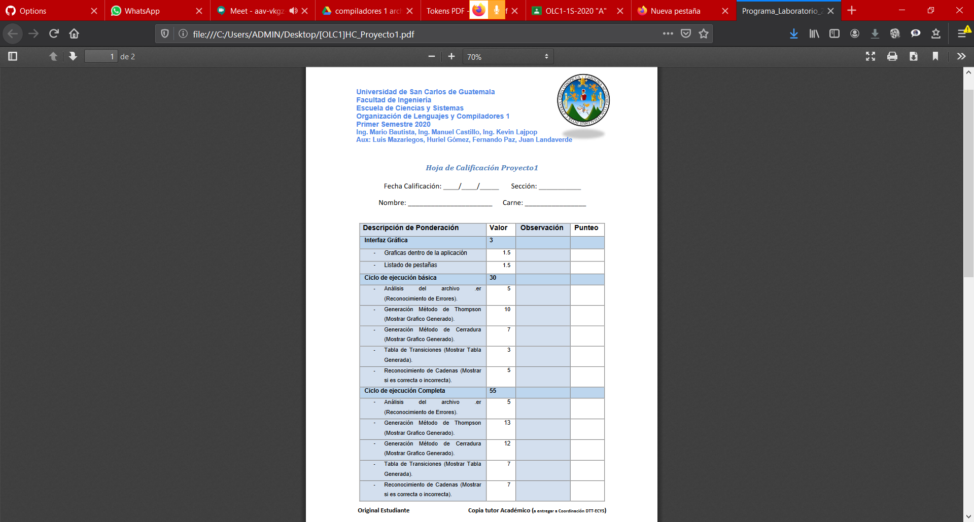

A

10 04 2020

Sergio Ariel Ramírez Castro

201020252

1.5

0.5

5

10

7

3

5

5

13

12

7

7

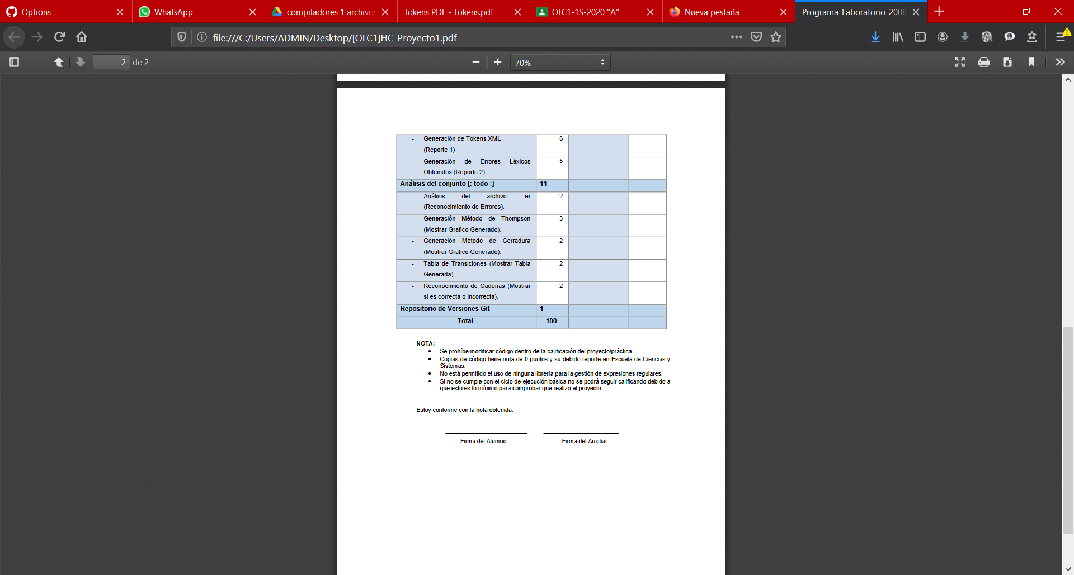

0

0

0

0

0

0

0

77

Sergio Ariel Ramírez Castro

1